**Address:**

To: Dr. Christopher Peters and Mr. David Cinciruk

From: Philip Mak and Sancheet Hoque

Date 4/26/2019

Re: Lab 2 - Week 2 (Lab)

**Introduction:**

The purpose of the second week of Lab 2 was to characterize the DC motor which will be used throughout the project. Students will learn how to utilize the PWM signal from the Arduino with the prelab. Following that, students use the automated lab equipment to get the RPM vs duty cycle characteristic plot through various calculation methods.

**Method/Analysis**

The circuit was set up between the Arduino, lab equipment, and new H-bridge board, powering providing the H-bridge with 12V. The PWM output from the Arduino goes into the Input pin of the H-bridge. The optical sensor on the H-bridge was attached to the oscilloscope. There was a pull-up resistor added between the 5V power and optical sensor signal in order to have well-defined voltage. The AWG was automated to cycle from 0V to 5V to 0V and back to 5V, as it will result in the varying duty cycles students wish to observe on the oscilloscope.

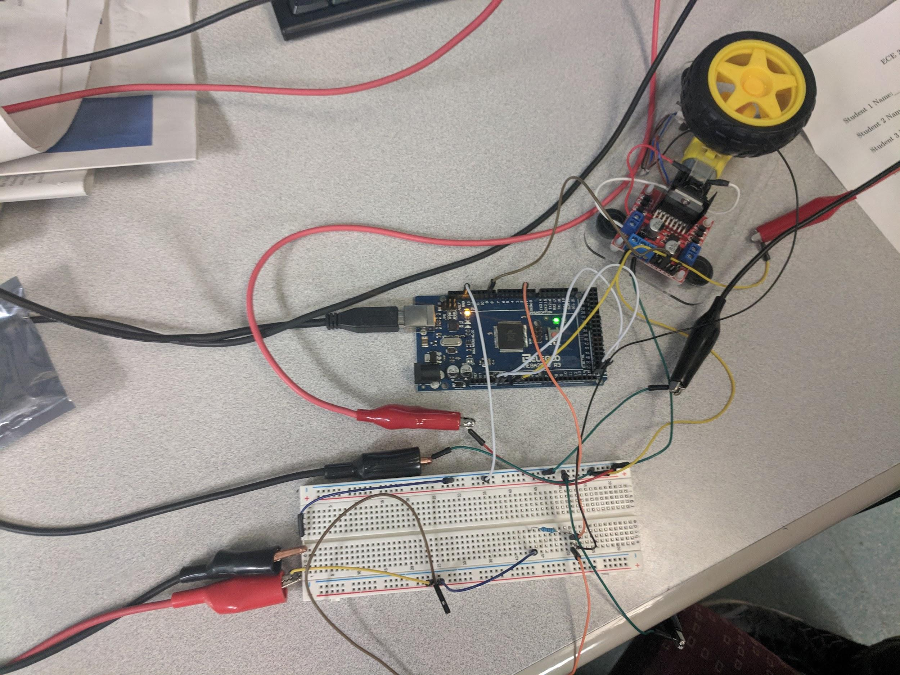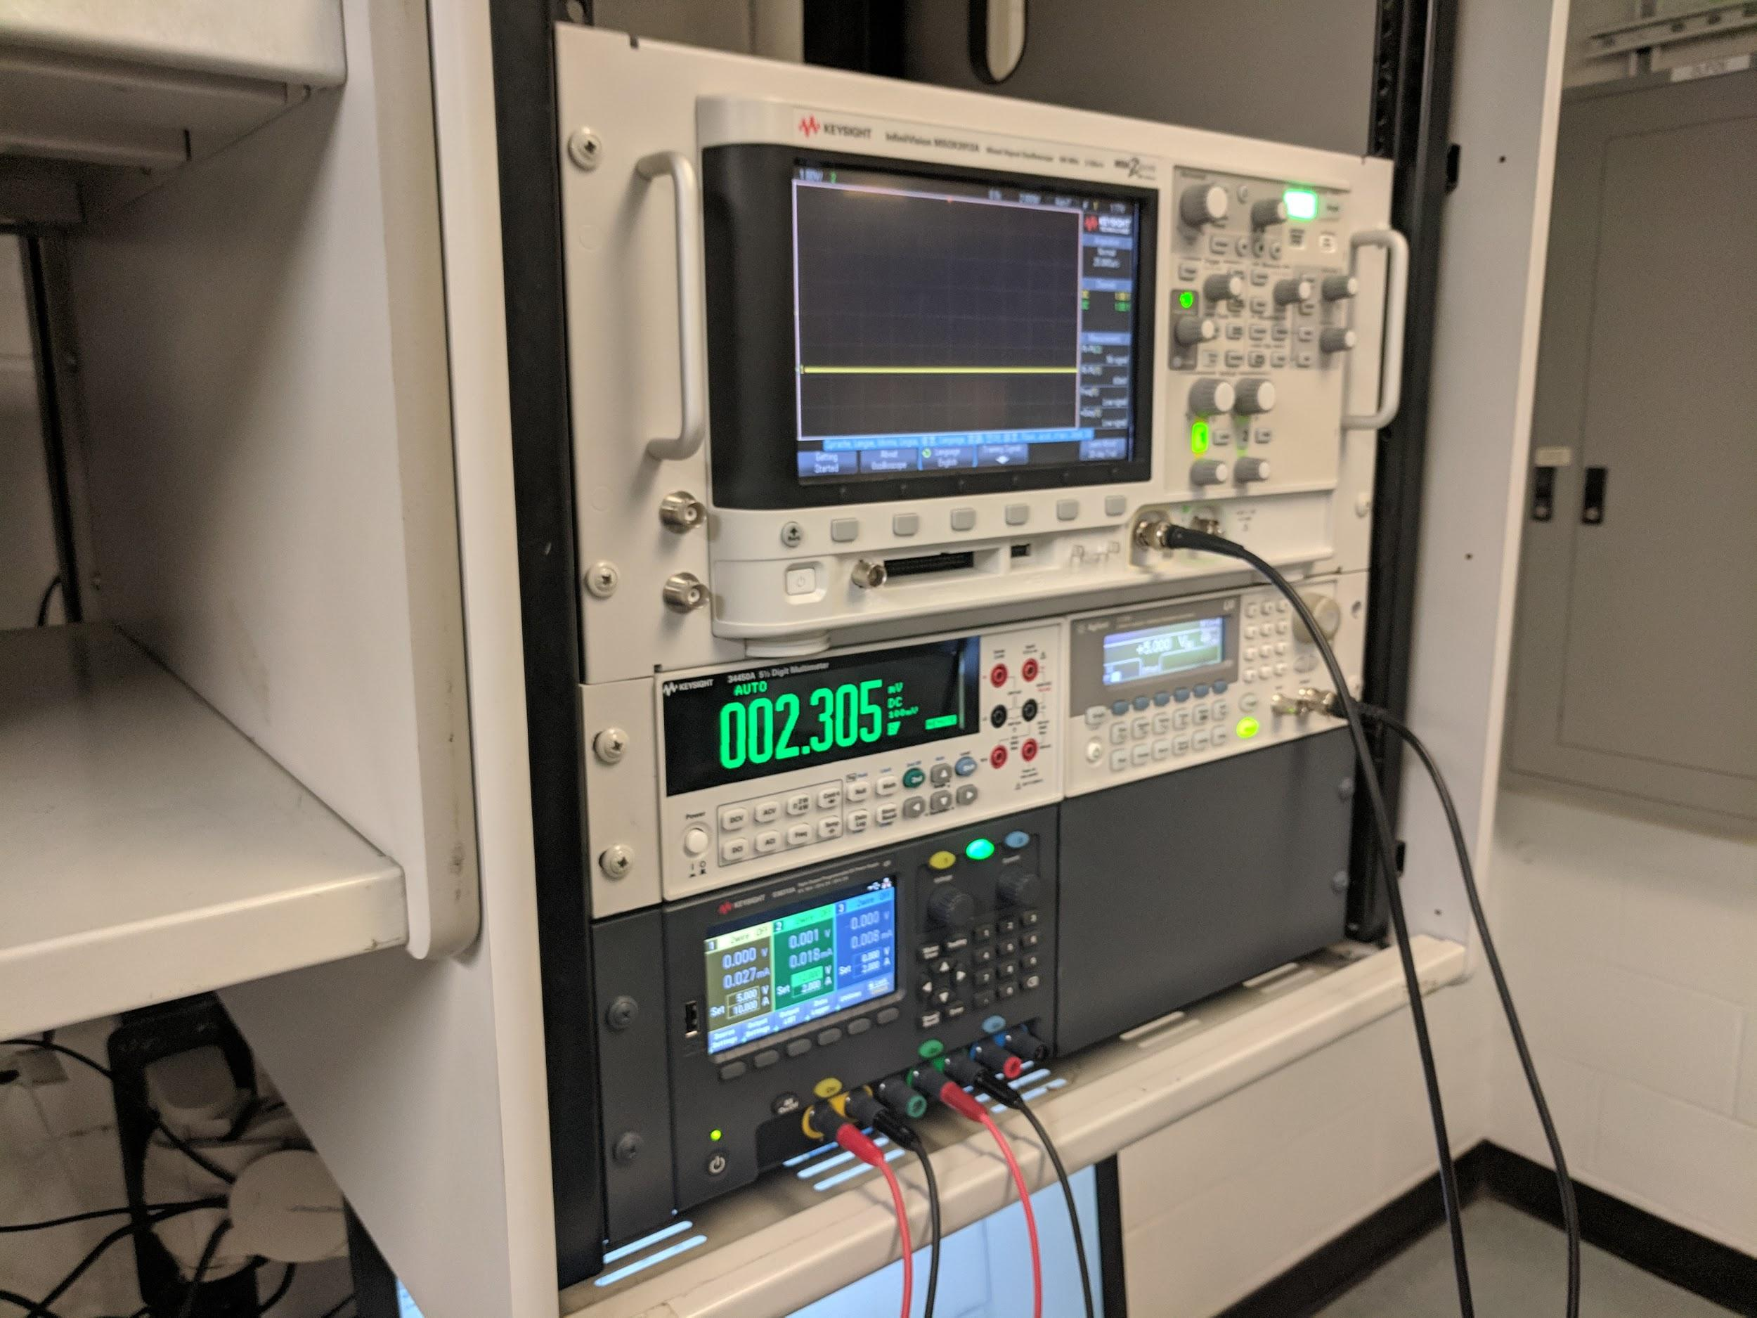

Figure I : Circuit involving breadboard, Arduino, H-Bridge(Left) and Lab Equipment(Right)

After setting up the DC motor board to the Arduino and ensuring wheel based on input from AWG, automation was done to collect data. For the Arduino side (Figure III), both part 1 and 2 of the pre-lab was combined into one script in which it outputted a PWM signal based on voltage from 0 to 5. Part 2 was used to count the pulse outputted by optical sensor. In MATLAB (Figure II), the visa commands were used to automate the voltage and extract the frequency. Serial commands were used to get the output from the Arduino. Both data sets were used to calculate the rpm of the wheel.

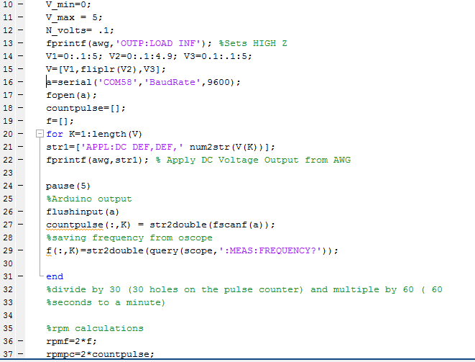

Figure II. Matlab automation and serial data retrieval

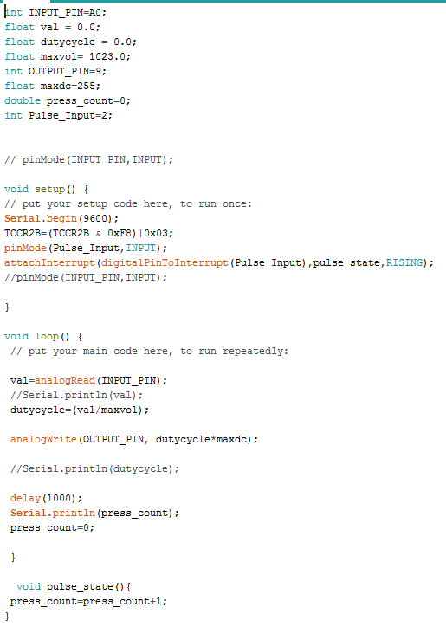

Figure III : Arduino PWM output and pulse counter

In each lab, RPM was plotted against the voltage points that were in 0.1V increments. The RPM was calculated by multiple 60 (the number of seconds in a minute) and divided by 30 to account for the number of holes in the circumference. The “Frequency Data” was found from the oscilloscope while the “Pulse Count” data was found from the optical sensor. The frequency plot and pulse count plot were represented separately along with their linear regression lines. The data was spliced into three sections and was used to get three linear regression lines. These three lines were then concatenated into one vector and plotted along their respective original data.

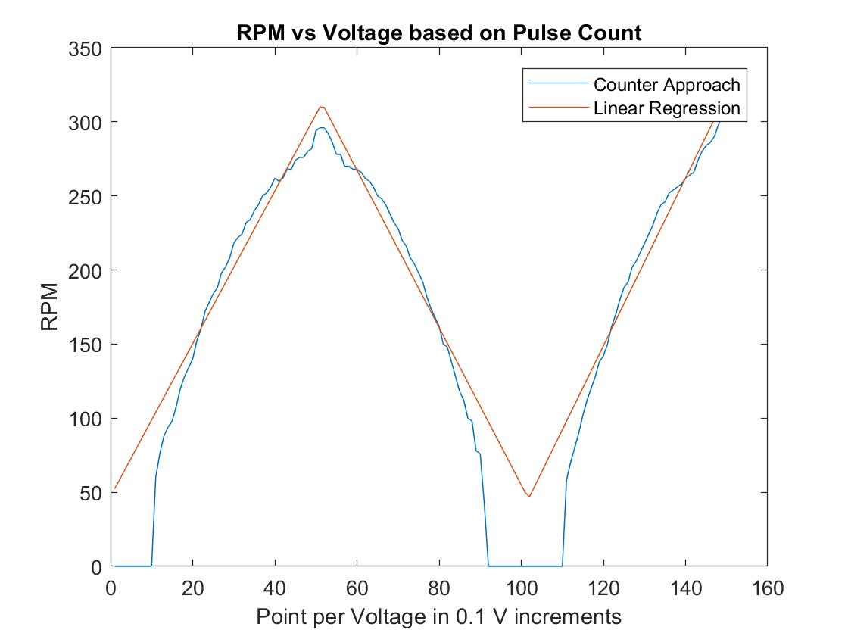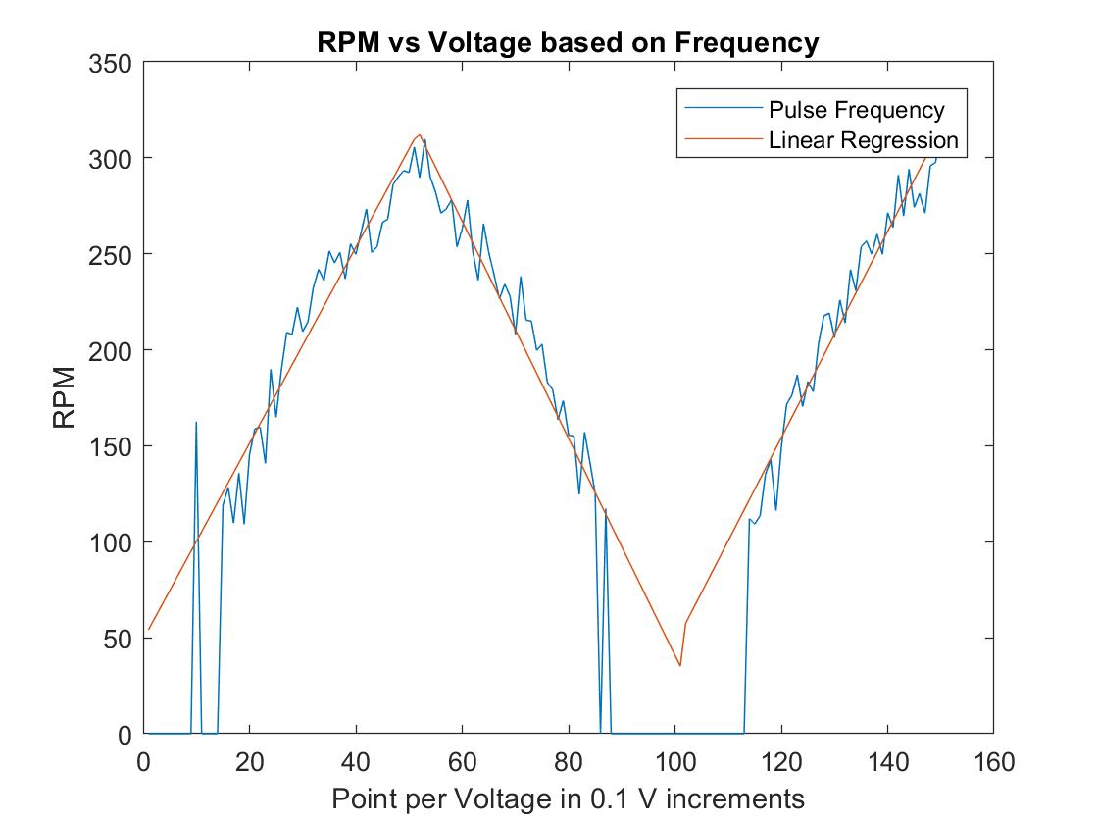

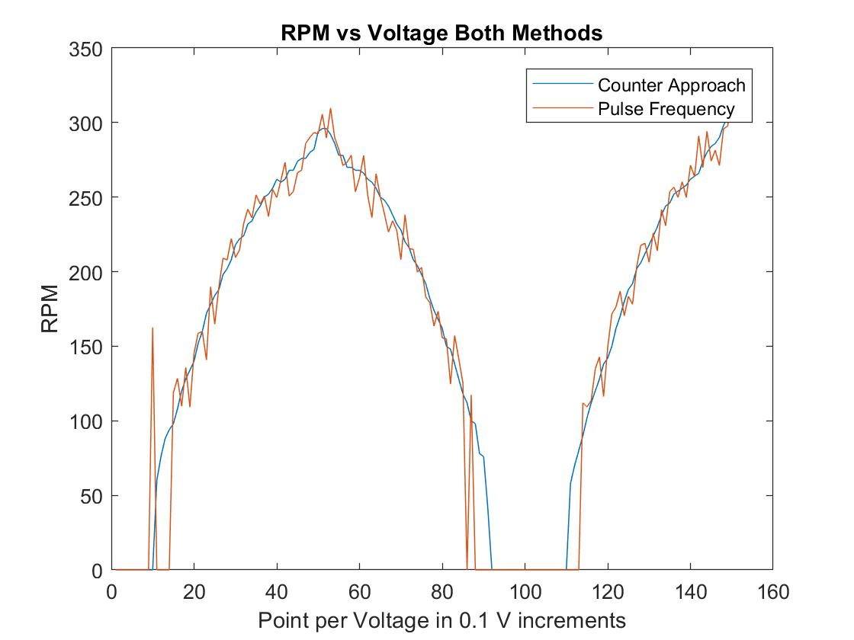

Figure IV :RPM vs Voltage: Via Pulse Count (Left), Via Frequency (Right), Both (Bottom)

**Discussion and Conclusion**

The DC motor is an important part of the project to come and be able to measure its RPM is a nice variable to have at hand for later calculations, such as efficiency or battery capacity. There were some issues with the equipment. For the frequency data, any points that were above a certain threshold was set to zero, due to the oscilloscope not being able to correctly measure frequency at low voltages.